# Supplementary

### Figure S1

This is the gating hierarchy generated from k means defined populations where k is 10. In this visualization, all gates including some redundant gates (for example node 11, 12, 31, and 32) are represented.

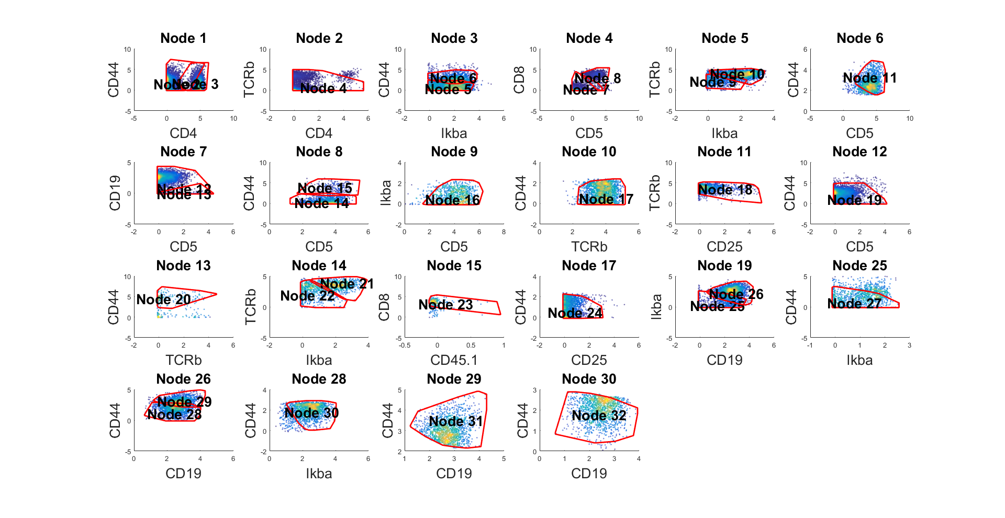

### Figure S2

a) This is the gating hierarchy generated from PhenoGraph defined populations with default parameters. b) The hierarchy tree. The number in the tree correspond to the node ID in a).

#### Figure S2a

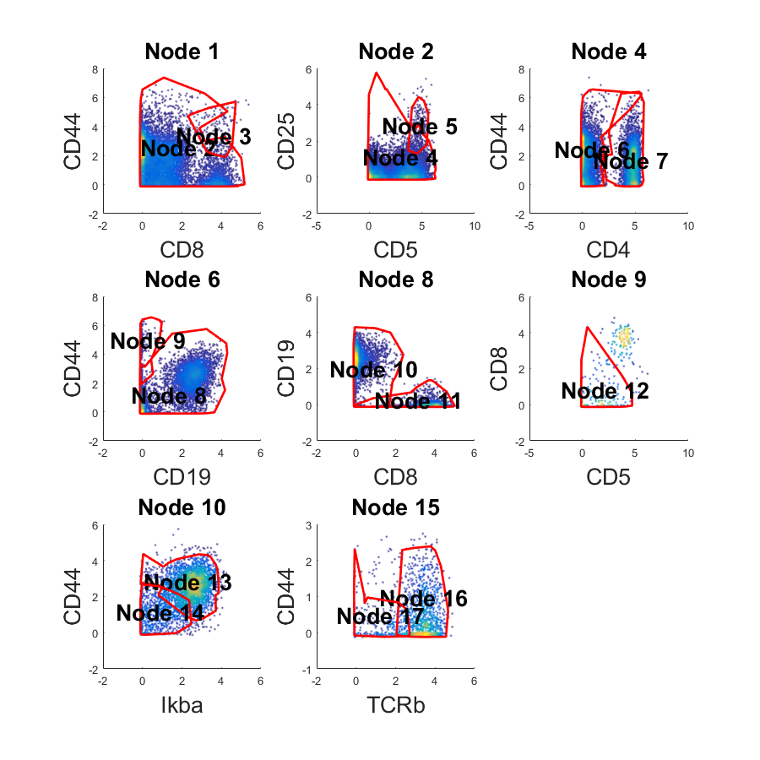

#### Figure S2b

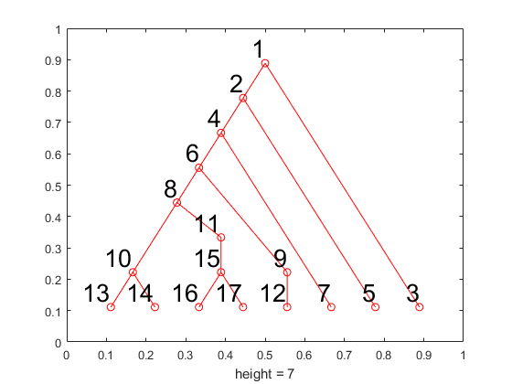

### Figure S3

a) Manual define four populations based on tSNE visualization. b) Gating hierarchy generated by the populations defined in a). c) Hierarchy tree.

#### Figure S3a



#### Figure S3b



#### Figure S3c

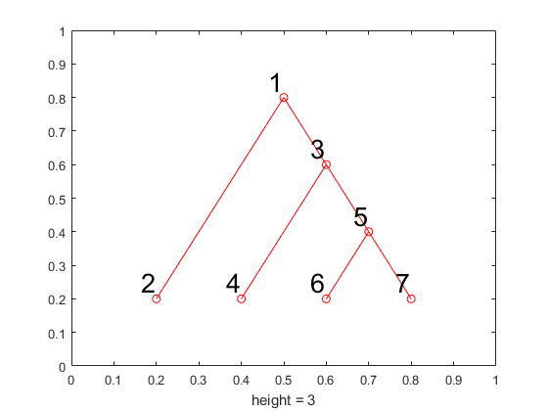

### Figure S4

Here’s the SPADE visualization of the CyTOF data. Each figure is colored differently by expression of different marker. Blue means low expression cells and red is high expression cells.



### Figure S5a-e

#### Figure S5a

Add 1% outlier cells of each population





#### Figure S5b

Add 2% outlier cells of each population





#### Figure S5c

Add 4% outlier cells of each population





#### Figure S5d

Add 8% outlier cells of each population



#### Figure S5d

Add 16% outlier cells of each population





#### Figure S5e

Add 32% outlier cells of each population. Up to node 17 are just redundant gates that exclude outliers.

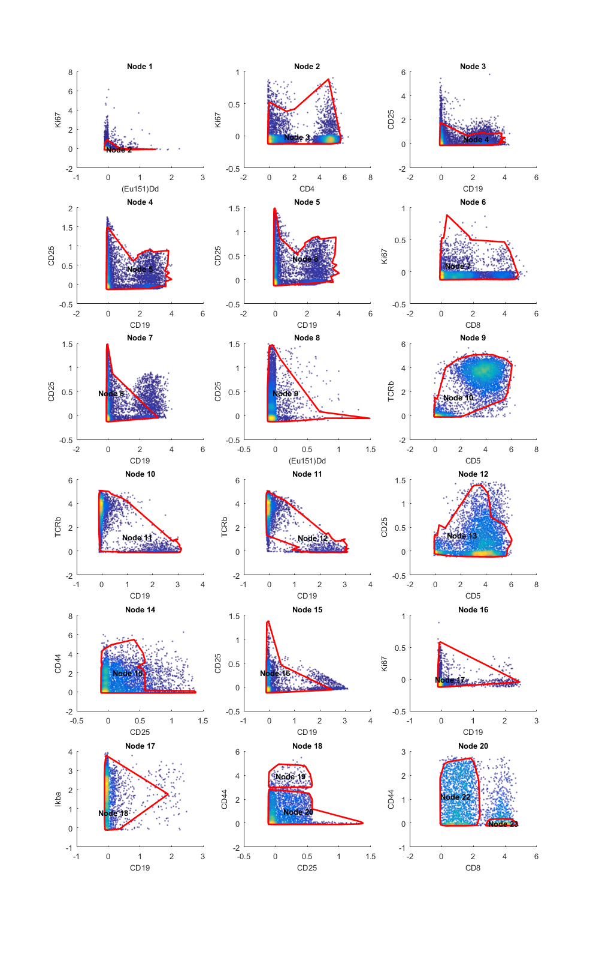

### Figure S6

C2G performance on 10 sub-sampled datasets. 10 cytometry data are sub-sampled from one k-means-clustered CyTOF data. Here is the generated gating hierarchy on the 10 sub-sample. Gates not shown are redundant gates that exclude small number of cells in one marker pair.



        

### Figure S7a-b

C2G results on larger CyTOF data. a) This is the gating hierarchy generated from kmeans defined populations. b) The hierarchy tree. The number in the tree correspond to the node ID in a). The redundant gates that only exclude a small number of unlabeled cells are not shown in a), for example, gates 51, 56, and so on.

#### Figure S7a

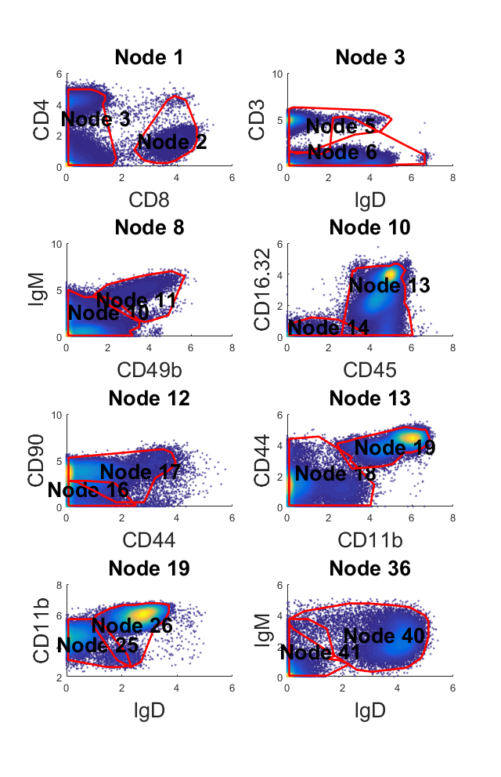

#### Figure S7b



### Table S1

Result on K-means defined populations

|  |  |  |  |  |  |
| --- | --- | --- | --- | --- | --- |
| Target Population | In Gate | True Positive | False Positive | False Negative | F-score |
| 1 | 27 | 746 | 155 | 42 | 0.883 |
| 2 | 16 | 798 | 139 | 115 | 0.863 |
| 3 | 32 | 1204 | 176 | 85 | 0.902 |
| 4 | 24 | 1853 | 243 | 277 | 0.877 |
| 5 | 31 | 1418 | 161 | 74 | 0.923 |
| 6 | 18 | 1163 | 165 | 208 | 0.862 |
| 7 | 21 | 714 | 27 | 38 | 0.956 |
| 8 | 20 | 138 | 12 | 18 | 0.902 |
| 9 | 22 | 609 | 38 | 46 | 0.935 |
| 10 | 23 | 192 | 15 | 26 | 0.904 |

### Table S2a

Phenograph results. Here, cell population 2, 3,7, and 8 are not separated and in the same gate; cell population 1 and 6 are not separated and in another gate.

|  |  |  |  |  |  |
| --- | --- | --- | --- | --- | --- |
| Target Population | In Gate | True Positive | False Positive | False Negative | F-score |
| 1 | 13 | 1721 | 1003 | 103 | 0.756816 |
| 2 | 7 | 1321 | 2962 | 0 | 0.471449 |
| 3 | 7 | 1281 | 3002 | 0 | 0.46046 |
| 4 | 16 | 1042 | 60 | 121 | 0.920088 |
| 5 | 14 | 796 | 218 | 137 | 0.817668 |
| 6 | 13 | 743 | 1981 | 58 | 0.42156 |
| 7 | 7 | 798 | 3485 | 0 | 0.314111 |
| 8 | 7 | 748 | 3535 | 0 | 0.297356 |
| 9 | 17 | 217 | 85 | 69 | 0.738095 |
| 10 | 5 | 205 | 150 | 61 | 0.660225 |
| 11 | 3 | 160 | 42 | 32 | 0.812183 |
| 12 | 12 | 131 | 21 | 20 | 0.864686 |

### Table S2b

Phenograph Results Merged

|  |  |  |  |  |  |
| --- | --- | --- | --- | --- | --- |
| Target Population | In Gate | True Positive | False Positive | False Negative | F-score |
| 1 | 13 | 2464 | 260 | 161 | 0.921294 |
| 2 | 7 | 4148 | 135 | 0 | 0.983988 |
| 4 | 16 | 1042 | 60 | 121 | 0.920088 |
| 5 | 14 | 796 | 218 | 137 | 0.817668 |
| 9 | 17 | 217 | 85 | 69 | 0.738095 |
| 10 | 5 | 205 | 150 | 61 | 0.660225 |
| 11 | 3 | 160 | 42 | 32 | 0.812183 |
| 12 | 12 | 131 | 21 | 20 | 0.864686 |

### Table S3

Results of tSNE defined clusters

|  |  |  |  |  |  |
| --- | --- | --- | --- | --- | --- |
| Target Population | In Gate | True Positive | False Positive | False Negative | F-score |
| 1 | 2 | 4415 | 32 | 0 | 0.996389 |
| 2 | 4 | 1565 | 29 | 41 | 0.978125 |
| 3 | 6 | 136 | 27 | 20 | 0.852665 |
| 4 | 7 | 3539 | 39 | 48 | 0.987858 |

### Table S4

Results of 100 nodes defined by SPADE. 11 cell populations are not properly separated from others and have a bad f-score (They are all in gate 195). The overall NMI is 0.63.

|  |  |  |  |  |  |
| --- | --- | --- | --- | --- | --- |
| Target Population | In Gate | True Positive | False Positive | False Negative | F-score |
| 1 | 23 | 38 | 21 | 24 | 0.628 |
| 2 | 20 | 55 | 27 | 15 | 0.724 |
| 3 | 95 | 73 | 34 | 13 | 0.756 |
| 4 | 246 | 54 | 18 | 18 | 0.750 |
| 5 | 26 | 19 | 34 | 20 | 0.413 |
| 6 | 160 | 70 | 40 | 28 | 0.673 |
| 7 | 298 | 109 | 63 | 34 | 0.692 |
| 8 | 195 | 95 | 2154 | 0 | 0.081 |
| 9 | 213 | 105 | 43 | 42 | 0.712 |
| 10 | 239 | 72 | 28 | 40 | 0.679 |
| 11 | 184 | 71 | 45 | 32 | 0.648 |
| 12 | 276 | 85 | 37 | 23 | 0.739 |
| 13 | 135 | 65 | 60 | 27 | 0.599 |
| 14 | 195 | 107 | 2142 | 12 | 0.090 |
| 15 | 13 | 19 | 8 | 31 | 0.494 |
| 16 | 112 | 51 | 32 | 32 | 0.614 |
| 17 | 67 | 61 | 28 | 13 | 0.748 |
| 18 | 142 | 87 | 40 | 35 | 0.699 |
| 19 | 156 | 69 | 41 | 27 | 0.670 |
| 20 | 217 | 62 | 50 | 29 | 0.611 |
| 21 | 280 | 92 | 55 | 28 | 0.689 |
| 22 | 259 | 68 | 60 | 21 | 0.627 |
| 23 | 97 | 64 | 16 | 12 | 0.821 |
| 24 | 228 | 59 | 46 | 46 | 0.562 |
| 25 | 195 | 220 | 2029 | 13 | 0.177 |
| 26 | 150 | 96 | 37 | 41 | 0.711 |
| 27 | 28 | 98 | 16 | 24 | 0.831 |
| 28 | 85 | 98 | 27 | 11 | 0.838 |
| 29 | 131 | 38 | 25 | 24 | 0.608 |
| 30 | 63 | 68 | 31 | 23 | 0.716 |
| 31 | 41 | 36 | 24 | 62 | 0.456 |
| 32 | 226 | 79 | 60 | 38 | 0.617 |
| 33 | 114 | 76 | 39 | 9 | 0.760 |
| 34 | 195 | 156 | 2093 | 2 | 0.130 |
| 35 | 17 | 50 | 33 | 21 | 0.649 |
| 36 | 125 | 52 | 41 | 41 | 0.559 |
| 37 | 278 | 71 | 65 | 28 | 0.604 |
| 38 | 306 | 123 | 80 | 34 | 0.683 |
| 39 | 266 | 62 | 22 | 23 | 0.734 |
| 40 | 62 | 44 | 19 | 10 | 0.752 |
| 41 | 50 | 53 | 31 | 0 | 0.774 |
| 42 | 153 | 73 | 48 | 21 | 0.679 |
| 43 | 197 | 60 | 15 | 20 | 0.774 |
| 44 | 209 | 48 | 38 | 19 | 0.627 |
| 45 | 221 | 47 | 28 | 68 | 0.495 |
| 46 | 32 | 29 | 35 | 18 | 0.523 |
| 47 | 126 | 41 | 27 | 36 | 0.566 |
| 48 | 195 | 174 | 2075 | 8 | 0.143 |
| 49 | 101 | 105 | 55 | 16 | 0.747 |
| 50 | 168 | 53 | 31 | 33 | 0.624 |
| 51 | 227 | 56 | 25 | 47 | 0.609 |
| 52 | 192 | 41 | 7 | 35 | 0.661 |
| 53 | 183 | 96 | 84 | 17 | 0.655 |
| 54 | 236 | 27 | 7 | 45 | 0.509 |
| 55 | 98 | 87 | 59 | 4 | 0.734 |
| 56 | 75 | 46 | 31 | 9 | 0.697 |
| 57 | 96 | 68 | 51 | 13 | 0.680 |
| 58 | 77 | 75 | 33 | 20 | 0.739 |
| 59 | 191 | 41 | 12 | 17 | 0.739 |
| 60 | 51 | 66 | 19 | 13 | 0.805 |
| 61 | 195 | 112 | 2137 | 14 | 0.094 |
| 62 | 69 | 57 | 22 | 4 | 0.814 |
| 63 | 277 | 67 | 45 | 29 | 0.644 |
| 64 | 179 | 71 | 35 | 23 | 0.710 |
| 65 | 138 | 7 | 1 | 70 | 0.165 |
| 66 | 174 | 81 | 44 | 37 | 0.667 |
| 67 | 307 | 74 | 71 | 39 | 0.574 |
| 68 | 90 | 42 | 17 | 26 | 0.661 |
| 69 | 297 | 68 | 36 | 45 | 0.627 |
| 70 | 34 | 45 | 43 | 7 | 0.643 |
| 71 | 164 | 43 | 15 | 29 | 0.662 |
| 72 | 53 | 52 | 29 | 46 | 0.581 |
| 73 | 187 | 66 | 38 | 26 | 0.673 |
| 74 | 169 | 124 | 75 | 6 | 0.754 |
| 75 | 89 | 81 | 52 | 38 | 0.643 |
| 76 | 248 | 77 | 106 | 32 | 0.527 |
| 77 | 52 | 33 | 10 | 6 | 0.805 |
| 78 | 273 | 93 | 52 | 15 | 0.735 |
| 79 | 222 | 68 | 65 | 46 | 0.551 |
| 80 | 281 | 97 | 77 | 22 | 0.662 |
| 81 | 6 | 68 | 29 | 12 | 0.768 |
| 82 | 195 | 127 | 2122 | 2 | 0.107 |
| 83 | 294 | 84 | 52 | 48 | 0.627 |
| 84 | 214 | 73 | 24 | 29 | 0.734 |
| 85 | 265 | 79 | 44 | 66 | 0.590 |
| 86 | 285 | 66 | 30 | 53 | 0.614 |
| 87 | 195 | 128 | 2121 | 4 | 0.108 |
| 88 | 195 | 126 | 2123 | 6 | 0.106 |
| 89 | 71 | 20 | 14 | 12 | 0.606 |
| 90 | 225 | 66 | 55 | 20 | 0.638 |
| 91 | 147 | 45 | 36 | 30 | 0.577 |
| 92 | 195 | 122 | 2127 | 5 | 0.103 |
| 93 | 46 | 74 | 46 | 1 | 0.759 |
| 94 | 38 | 126 | 36 | 22 | 0.813 |
| 95 | 305 | 40 | 27 | 31 | 0.580 |
| 96 | 195 | 106 | 2143 | 3 | 0.090 |
| 97 | 231 | 54 | 53 | 28 | 0.571 |
| 98 | 170 | 44 | 38 | 37 | 0.540 |
| 99 | 181 | 51 | 34 | 14 | 0.680 |
| 100 | 270 | 83 | 86 | 19 | 0.613 |

### Table S5

k-means defined cell populations on larger CYTOF dataset. Here, cell population 3 and cell population 6 are not separated. And the overall NMI is 0.833.

|  |  |  |  |  |  |
| --- | --- | --- | --- | --- | --- |
| Target Population | In Gate | True Positive | False Positive | False Negative | F-score |
| 1 | 34 | 15071 | 509 | 1491 | 0.938 |
| 2 | 53 | 6630 | 250 | 597 | 0.940 |
| 3 | 26 | 10863 | 14070 | 1338 | 0.585 |
| 4 | 61 | 17494 | 85 | 2641 | 0.928 |
| 5 | 57 | 9833 | 301 | 1164 | 0.931 |
| 6 | 26 | 13421 | 11512 | 784 | 0.686 |
| 7 | 4 | 13324 | 35 | 442 | 0.982 |
| 8 | 58 | 29331 | 833 | 1526 | 0.961 |
| 9 | 28 | 6993 | 460 | 398 | 0.942 |
| 10 | 67 | 5476 | 68 | 3054 | 0.778 |